**User Guide**

1. **Getting Started with To-Do-This**

**Command words**

|  |  |  |  |  |  |
| --- | --- | --- | --- | --- | --- |
| **Add** | **Label** | **Delete** | **Edit** | **Done** | **Search** |
| **Hide** | **Display** | **Undo** | **Redo** | **Help** |  |

**Adding Tasks**

* Command Word  
  you have the option of either typing the **command word** “add” or omitting it for your convenience.

complete CS2101 reflection

**add** complete CS2101 reflection

* Use of preposition words  
  To-Do-This has a certain level of natural language processing. The following list of ‘**preposition words’** will be omitted in the Task Details if followed by a *time* or *date*.

**Preposition Words**

|  |  |  |  |  |  |  |
| --- | --- | --- | --- | --- | --- | --- |
| On | At | By | To | - |  |  |
| From | Till | Until | About | The |  |  |
| Next | Following | This |  |  |  |  |

Complete assignment **by** *Monday* **at** *2pm*

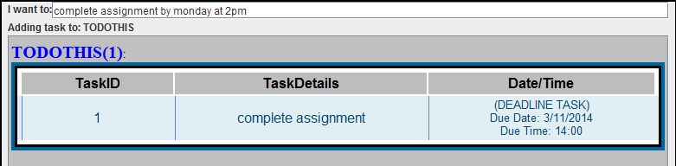

Study in school **from** *6pm* **–** *8pm* **on the** ***following*** *monday*

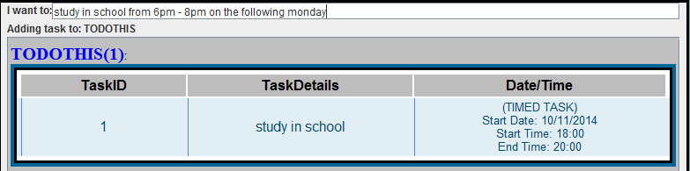

* Date and Time formats supported.  
  There are various date and time formats that To-Do-This supports. For time inputs, both the 12-hour formats and 24-hour formats are supported with certain amount of flexibility. For date inputs, shortened forms of the year and the spelling of the months are acceptable. The boxes below show the list of various formats that you may use.

**Date**27 October 2014 / 27 October 14  
27 Oct 2014 / 27 Oct 14  
27 Oct  
DD/MM/YYYY  
DD/MM/YY  
DD-MM-YYYY   
DD-MM-YY  
DDMMYYYY  
DDMMYY

**Time**

12 Hours format

3pm

3:00 / 3:00pm

300pm

3.00 / 3.00pm

24 Hours format

15:00pm

1500pm

1500h/hr/hrs

To-Do-This also takes the following words that represent a specific day and translates them into a date.

Buy eggs *this Tuesday*

**Days**  
Today  
Tomorrow  
Next day  
Following day  
Monday (etc)

Buy bread *next Wednesday*

Buy biscuits *tomorrow.*

The time and date inputs can be entered with or without the use of prepositions before the word itself.

Play board games *5pm 23/12/14*

All the date inputs will be translated and appear in the format **DD/MM/YYYY** while all the time inputs will appear in **24-hours format.**

* Types of Tasks supported.  
  There are 3 types of tasks that To-Do-This supports.

1. Timed tasks – tasks with a specific range of time
2. Deadline tasks – tasks with a specific deadline
3. Floating tasks – tasks without deadlines.

* Position of Date/Time words.  
  The position of the date and time in the entire input you enter does not matter. However, the start date and/or time has to be **before** the end date and/or time.

Party in town from *4 dec 5pm* to *5 dec 3am*

From *9pm* till *6am* on *3/12/14* Party in town

* Use of “ “.  
  As certain words of your desired Task Details may be recognised by To-Do-This as a date, day or month etc, To-Do-This provides you with a method to enter those words which would appear only in the **Task Details**. Everything entered within a **“ “** would appear exactly in the **Task Details**. It will not be recognised as a date, time or command word. It would also not be recognised as having priority.

Watch movie **“the day after tomorrow”** on Sunday at 3pm

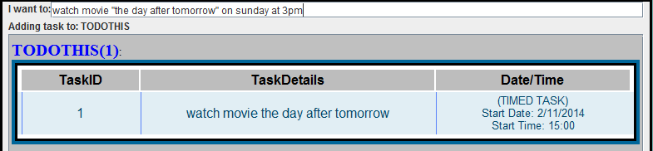

“**edit video for dance BLAST!”** by 5pm today

* Priority Tasks  
  The presence of an exclamation mark ! determines that a task is of **priority**. A priority task is coloured pink. The presence of an **!** within the “ “ would not be recognised as a priority task.

Watch Maze Runner before it stops screening**!**

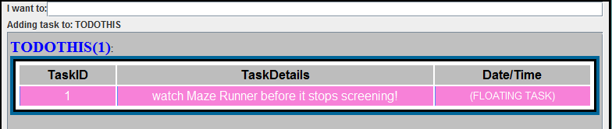

**Labels**

* Adding new Labels

A label name has to be of one word. Label names are not case sensitive and will be displayed in upper case. The number beside each label shows the number of tasks in that specific label.

**Label** tomorrow

**Label** SHOPPINGLIST

A default label TODOTHIS.

* Changing the current label you are at

If a label named “TOMORROW” has already been created before, this command

**Label** tomorrow

This command would change the current directory to TOMORROW. The label TOMORROW will be displayed at the top and you will now be able to add tasks under this label.

**Delete**

* Deleting a task

To delete a specific task from the current label you are at, simply include just the Task ID.

Delete **1**

To delete a specific task from another label, for example TOMORROW, include the Label name before the Task ID.

Delete tomorrow **1**

* Deleting a label  
  To delete a label and all its contents

Delete tomorrow

* Deleting everything

Just entering the **Command word** ‘delete’ deletes all the labels and tasks available.

**Delete**

**Edit**

* Editing a task under current label

Every task is tagged with a **Task ID**. A specific task can be edited by specifying its task ID. The previous Task Details of that task ID will be auto displayed out on the command line. You may choose to edit the task from the previous details for your convenience.

Edit **1** buy 2 boxes of eggs this tuesday

Before command:

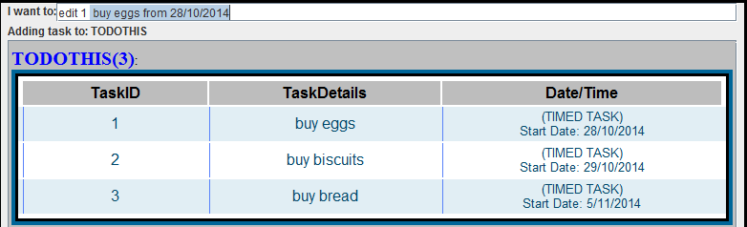

After Command:

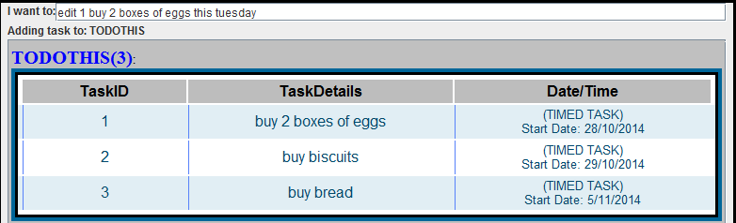

* Editing a task from another label

If you are currently under the label TODOTHIS and you wish to edit a task with task ID **2** under the label TOMORROW,

Edit tomorrow **2** buy 4 cartons of drinks

**Done**

* Marking a task as completed

After completing a task, you may wish to mark it done instead of deleting it totally from the list. A task that has been marked done will be strike out and highlighted in green. Marking a task that has already been marked done will switch it back to undone.

To mark task 1 from the current label as done

Done **1**

To mark task 2 from another label such as TOMORROW as done, the label name has to be included before the Task ID.

Done **tomorrow 2**

To mark all tasks under all the labels as done, simply enter just the **command word** ‘done’ alone.

**Done**

* Marking a label as completed

To-Do-This allows users to mark all the tasks under a label as done at one go.

Done **todothis**

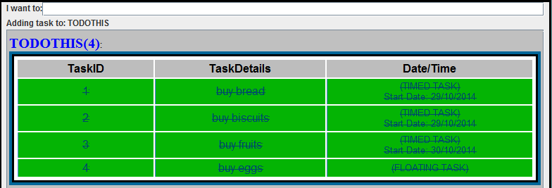

**Search**

* Searching by keywords  
  you can search through all the labels by entering more than one **keyword**. Tasks (including those already marked as done) consisting of those keywords will be displayed with their labels accordingly. If no keyword is entered, the entire list of all tasks and labels will be displayed.  
    
    
  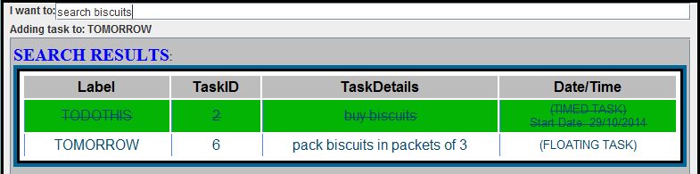

Search **biscuits**

* Searching by date  
  To-Do-This also allows users to search for tasks by date. Simply include a ‘**@**’ before the desired date / day.

Search **@**25/12/14

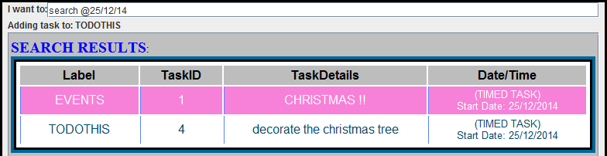

For example, if today’s date is 28/10/2014,   
  
  
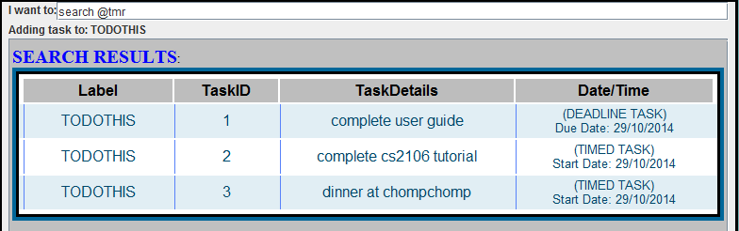

Search **@**tmr

**Hide & Display**

* Hiding / Displaying the view of labels.

Display and Hide works the same way. You may choose to hide/ display the view of one or more labels. The other labels not stated will remain displayed/ hidden.

To display the view of one label, enter the label name.

Display todothis

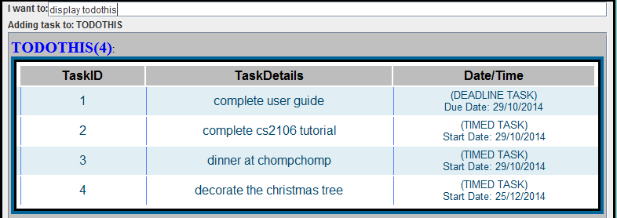

To hide the view of 2 labels, enter both the label names.

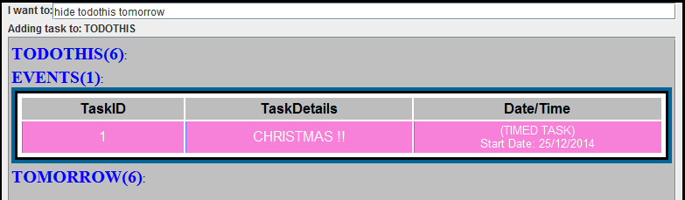

Hide todothis tomorrow

To hide / display the view of all the labels and tasks, simply enter just the **command word Hide** or **Display.**

**Undo & Redo**

* To undo previous command(s)  
  The undo feature allows you to undo not just the previous but all the previous commands. Undo reverts the changes.

**Undo**

When you undo a **search** / **help** command, To-Do-This will display the screen same as what was displayed before that search / help command took place.

* To redo an undo command  
  the redo command reverses the effect of the undo command that took place. You are only allowed to enter the redo command the same number of times you have entered the undo command.

**Redo**

**Help**

1. **Other features**

**Overdue tasks**

Overdue tasks (task with deadlines that have already passed) are highlighted in red. This is to attract your attention and remind you that the task should have been completed.

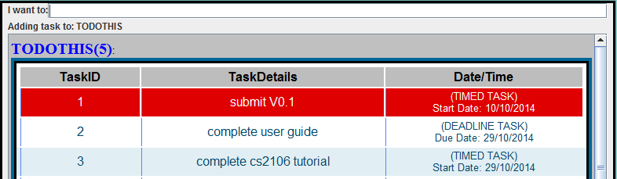

**Auto Complete**

The following words will be auto-completed when To-Do-This recognises the user typing in a similar sub-string (part of the word). This feature is in place to increase your typing speed, as well as to help you decrease the number of keystrokes needed in order to complete a word or sentence.

* All command words except ‘add’.
* Label names
* Task details when entering the edit command.

**Hot Keys**

There are some hotkeys as shortcuts for certain functions. They serve the purpose of allowing users to rely solely on their keyboard when using To-Do-This.

|  |  |
| --- | --- |
| Shortcut | Function |
| Ctrl + Z | **Undo** |
| Ctrl + Y | **Redo** |